Virtual Machines

Step 1: Create Virtual Machines

Now we will click to the “VNETpeering” which is created resource group then click to
“Create” and search for “Virtual machine” and click on the top searched option and then click
to “Create” and then give a name in the “Virtual machine name” section like “VM1” and
select “Window 10 pro” in “Image” section and give a “Username” and “Password” of your
choice and check the checkbox in Licensing section. Now move to Monitoring and select
“Disable” in “Diagnostics” section. At last in “Review + create” section click on “Create” to
create the virtual network.

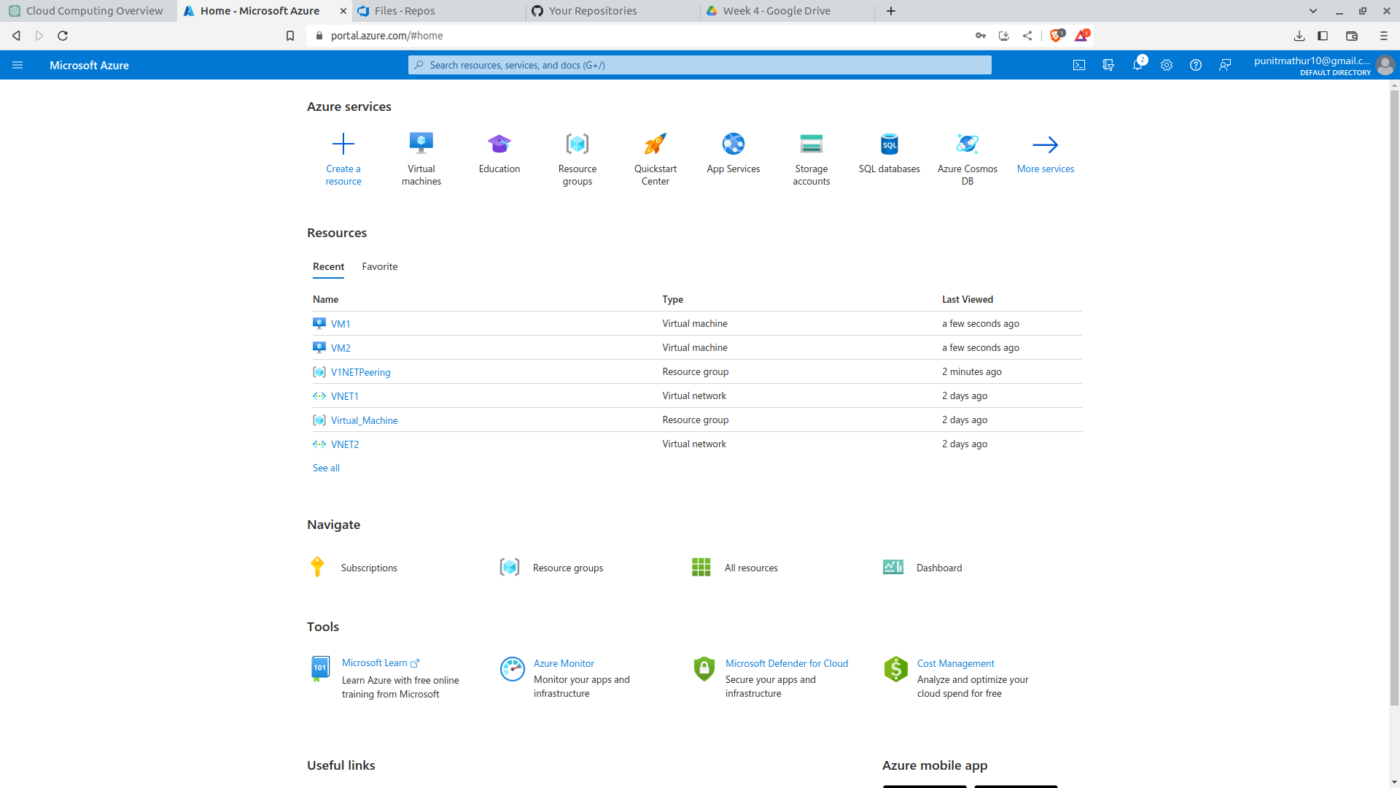
Note- Follow the above same steps for creating VM2 as well

Step 2 : Run and Configure Virtual Machines Remotely

Search for “Remmina” in your PC’s home page search bar and
paste the VM1’s “Public IP address” which you will find on clicking the VM1 and fill the
Username and Password and click Submit and then click Yes. Then search for “Windows
Defender Firewall” and in “Turn Windows Defender Firewall on or off” and turn both “Public
network settings” and “Private network settings” off. Now search for “Windows PowerShell”
and run commands “hostname” and “ipconfig”.
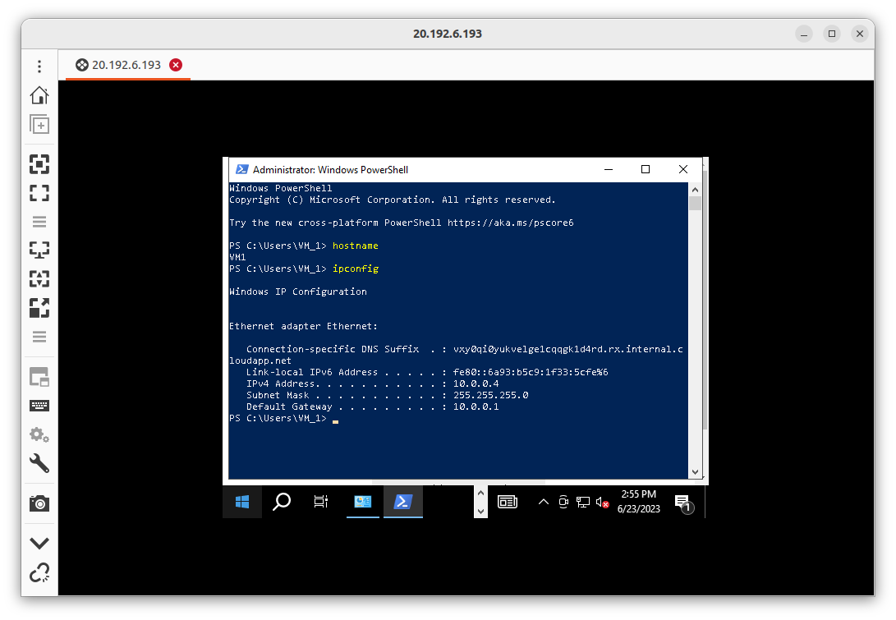

Note- Repeat these steps in VM2 as well

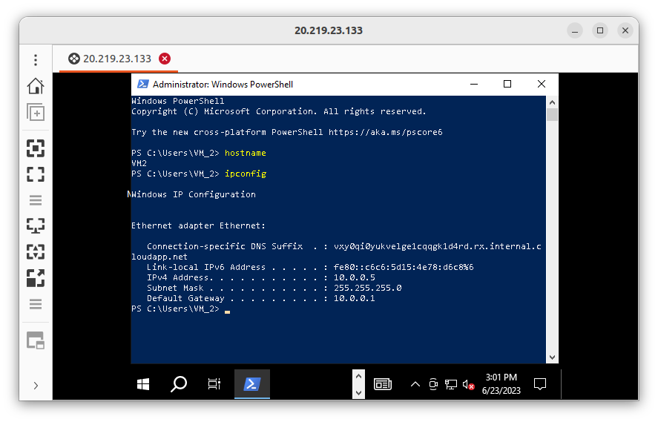

Step 3 :- Establishing Connections between both the VMs

Now run the “Windows Powershell” and in the powershell, run the commands :-
“ping IPv4 Address of VM2 machine”
in VM1 Machine command (ping 10.0.0.5)
“ping IPv4 Address of VM1 machine”
in VM2 machine command (ping 10.0.0.4)

